Ex.No : 17

Date : 14.12.2021 **LOGIN FORM USING CSS**

**AIM:**

To write a program to display login form using HTML and CSS.

**Procedure:**

* Click start🡪All programs🡪 Notepad or Window+R to open Notepad.
* Type notepad and press OK button and notepad will be opened.
* Use HTML tags to give login form contents.
* Use appropriate CSS style coding <style> to design then login form.
* Set the properties like border, button, image and labels.
* Save the program with extension .html
* Run the program in web browser.
* Close the program.

**Program**

<!DOCTYPE html>

<html>

<style>

/*set border to the form*/

form {

border: 2px solid #f1f1f1;

}

/*assign full width inputs*/

input[type=text],

input[type=password] {

width: 50%;

padding: 12px 20px;

margin: 5px 0;

display: inline-block;

border: 1px solid #ccc;

box-sizing: border-box;

}

/*set a style for the buttons*/

button {

background-color: #4CAF50;

color: white;

padding: 14px 20px;

margin: 8px 0;

border: none;

cursor: pointer;

width: 50%;

}

/* set a hover effect for the button*/

button:hover {

opacity: 0.8;

}

/*set extra style for the cancel button*/

.cancelbtn {

width: auto;

padding: 10px 18px;

background-color: #f44336;

}

/*centre the display image inside the container*/

.imgcontainer {

text-align: center;

margin: 8px 0 12px 0;

}

/*set image properties*/

img.avatar {

width: 20%;

border-radius: 30%;

}

/*set padding to the container*/

.container {

padding: 16px;

}

/*set the forgot password text*/

span.psw {

float: right;

padding-top: 16px;

}

/*set styles for span and cancel button on small screens*/

@media screen and (max-width: 300px) {

span.psw {

display: block;

float: none;

}

.cancelbtn {

width: 50%;

}

}

</style>

<body>

<h2>Login Form</h2>

<!--Step 1 : Adding HTML-->

<form action="/action_page.php">

<div class="imgcontainer">

<img src=

"F:\Thesis\image.jpg" height=150 alt="Avatar" class="avatar">

</div>

<div class="container"><H1>

<label><b>Username</b></label>

<input type="text" placeholder="Enter Username" name="uname" required><BR>

<label><b>Password</b></label>

<input type="password" placeholder="Enter Password" name="psw" required>

<button type="submit">Login</button>

<input type="checkbox" checked="checked"> Remember me

</div>

<div class="container" style="background-color:#f1f1f1">

<button type="button" class="cancelbtn">Cancel</button>

<span class="psw">Forgot <a href="#">password?</a></span></H1>

</div>

</form>

</body>

</html>

**OUTPUT**

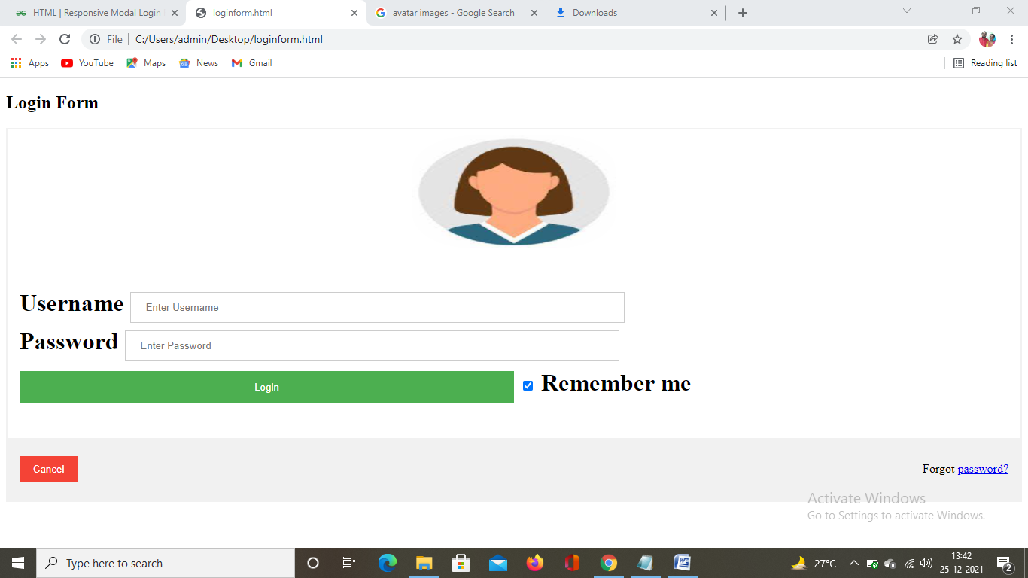

**RESULT**

Thus the program to create login webpage using HTML and CSS was created and executed successfully.

Ex.No : 18

Date : 15.12.2021 **MOBILE SHOWROOM ADVERTISEMENT**

AIM:

To write a program to display Mobile showroom advertisement using HTML and CSS.

Procedure:

* Click start🡪All programs🡪 Notepad or Window+R to open Notepad.
* Type notepad and press OK button and notepad will be opened.
* Use HTML tags to give Mobile showroom contents.
* Use appropriate CSS style coding <style> to design then webpage.
* Set the properties like background image and button.
* Save the program with extension .html
* Run the program in web browser.
* Close the program.

**Program**

<!DOCTYPE html>

<html>

<head>

<meta name="viewport" content="width=device-width, initial-scale=1">

<style>

body {

margin: 0;

font-family: Arial, Helvetica, sans-serif;

}

.hero-image {

background-image: url("MOBILE5.jpg");

background-color: #cccccc;

height: 500px;

background-position: center;

background-repeat: no-repeat;

background-size: cover;

position: relative;

}

.hero-text {

text-align: center;

position: absolute;

top: 30%;

left: 50%;

transform: translate(-50%, -50%);

color: GREEN;

}

</style>

</head>

<body>

<div class="hero-image">

<div class="hero-text">

<h1 style="font-size:50px">WELCOME</h1>

<h3>EXPERIENCE THE BEST PURCHASE</h3>

<button>GO</button>

</div>

</div>

</body>

</html>

**OUTPUT**

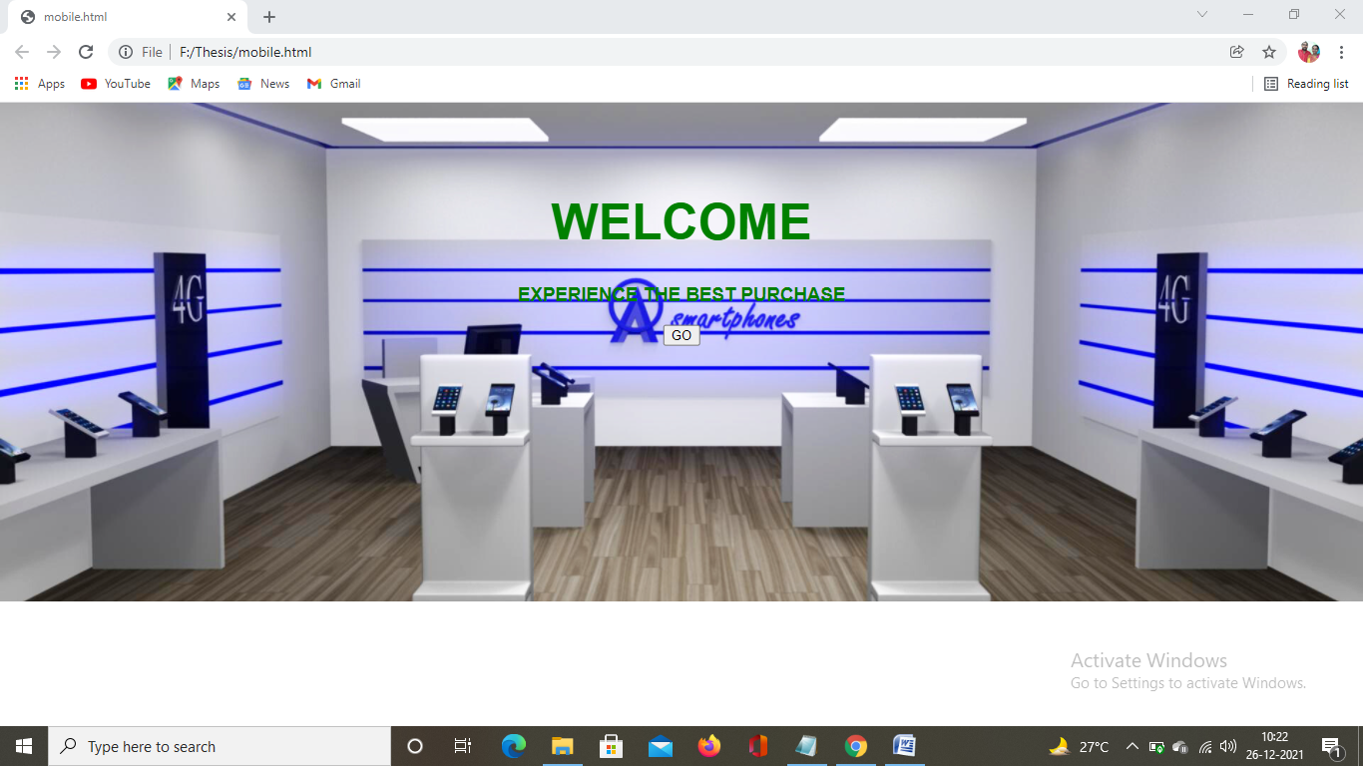

**RESULT**

Thus the program to create Mobile showroom advertisement using HTML and CSS was created and executed successfully.